Checkpoint 1

### Team : Molly Tarter

**Link to Github repository :** <https://github.com/MollyCTarter/Agrivoltaics>

**Dataset chosen :** PVWatts dataset (Data that estimates potential solar energy output of specific locations)

**Source :** <https://developer.nrel.gov/docs/solar/pvwatts/v8/>

**Why this dataset? :**

This dataset enables the collection of data for **specific latitude and longitude** coordinates, which is critical for identifying agricultural areas in Maryland that could benefit from **agrivoltaics**. Agrivoltaics maximizes **agricultural land** usage via the installation of solar panels **above** crops and livestock currently on the land. This system provides a unique opportunity for large **food corporations**, as well as **privately owned farms**, to cooperate with renewable energy organizations on solving **two** major problems: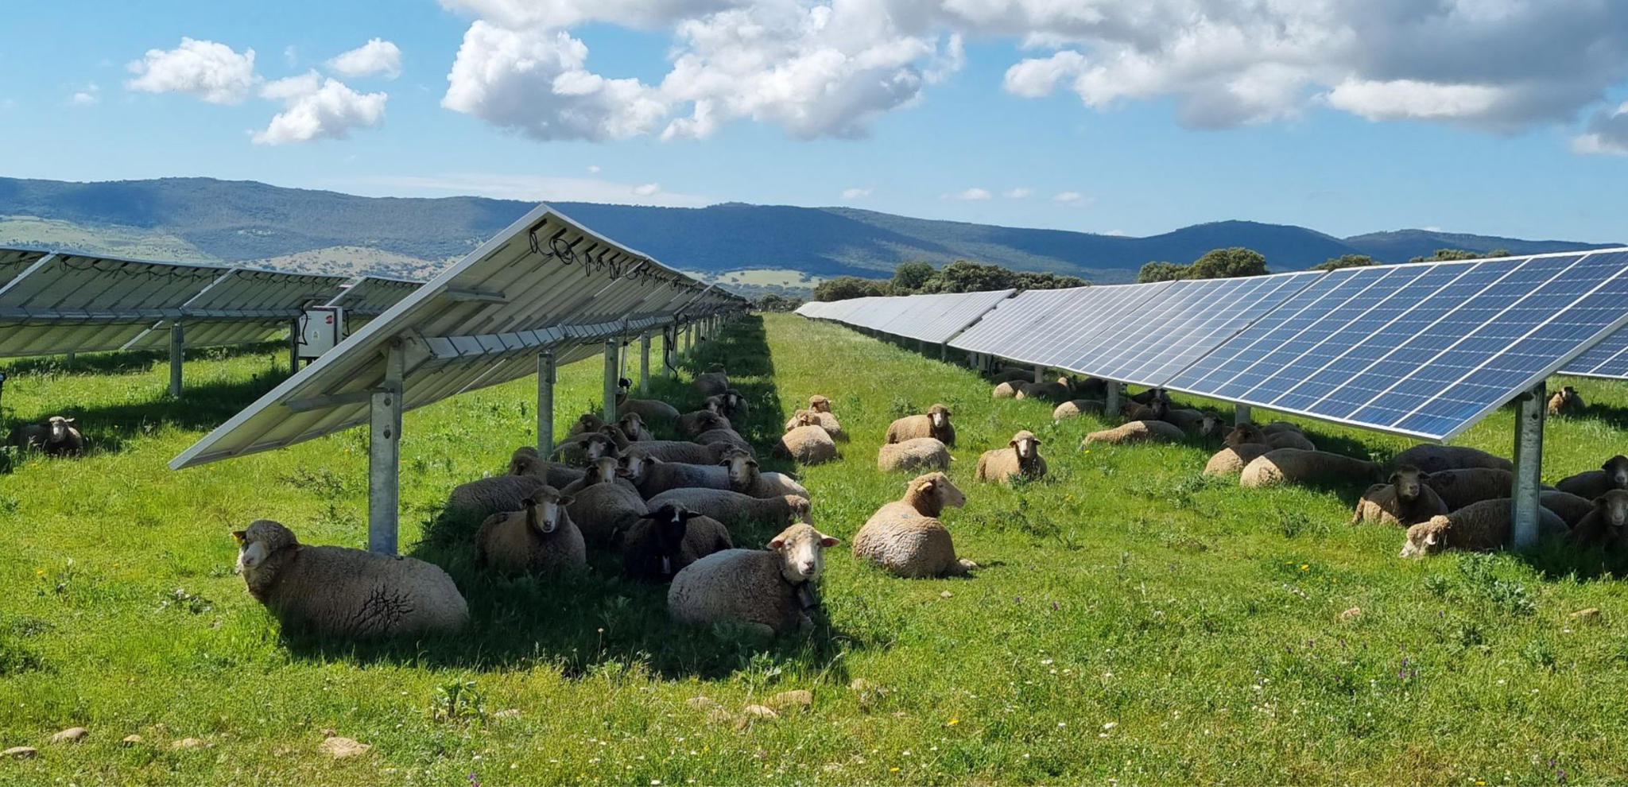

1. **Competition for land** between agricultural farmers and solar farmers.
2. Environmentally **unsustainable business operations** on agricultural land.

[Photo Source](https://www.enelgreenpower.com/media/news/2022/12/agrivoltaics-benefits-world-agriculture)

There are **incentives for corporations** to install agrivoltaic systems **beyond upholding the public’s perception** of their sustainability practices. Benefits that agricultural farmers and large corporations will be interested in include :

1. Protection of crops and soil from heat and wind, **increasing crop yields** and **crop diversification.**
2. Reduction in water evaporation, **cutting down costs** on water usage.
3. Potential to sell solar power generated from the panels, **offsetting revenue fluctuations** in an often **volatile agricultural market.**

**\***A benefit worth noting is that the installation and maintenance of agrivoltaics will stimulate the American economy, most specifically **benefitting rural communities** that are oftentimes the most economically disadvantaged in the United States.

**The Goal** of this project is to identify agricultural land in Maryland by latitude and longitude, then collect data for these specific locations. This data will identify areas best suited for agrivoltaics. There are numerous correlations to observe as well, including **daily and seasonal solar energy fluctuations,** as well as the potential relationship between the **seasonality of a crop** and the resulting agrivoltaics benefits. The dataset updates hourly, with historical data from a year back.

It is significant to note that many large corporations have pledged to achieve **net-zero greenhouse gas emissions by 2050**. This aligns with the **Paris Agreement**, adopted in 2015 and signed by every country in the United Nations in 2016, where each country committed to lowering global greenhouse gas emissions to below **pre-Industrial Revolution levels.** This directly translates into solar data being increasingly more relevant for data scientists, as corporations pay greater attention to sustainability metrics.